PROJECT 2

Environment Monitor Station

Date August 14, 2026

GitHub: github.com/arlengj995-bit

Two sensors measure three environmental quantities: a DHT11 measures temperature and humidity, and a light-dependent resistor (LDR) measures light level. An LCD shows all three readings live. A Python logger on my computer was configured for 30 minutes; the submitted session contains 400 readings over 13 minutes 35 seconds. I deliberately covered the light sensor, breathed on the DHT11, and turned the room light off. The recorded changes show the sensors responding to these events.

1. What This Project Does
This project measures temperature, humidity, and light level. All three update on an LCD approximately every 2 seconds and are sent to my computer over USB. A Python script collects the readings, saves them to a CSV file after collection ends, and draws a graph.
I logged the readings to observe how the sensors responded to deliberate changes. During the submitted session I covered the LDR, breathed on the DHT11, and turned the room light off. The graph shows corresponding changes in light level, temperature, and humidity. These responses support the operation of the monitor, although this test does not establish absolute sensor accuracy.
This is the second of ten projects building toward an automated aquarium controller. The aquarium needs to monitor temperature, light, pH, and CO₂ simultaneously, all day, every day. This project monitors temperature, humidity, and light; it does not yet measure pH or CO₂. The sensor reading pipeline, the error checking, and the CSV data logging structure I built here are the same patterns the aquarium controller will use. The components change but the approach stays the same.

2. How the Sensors Work

2.1 DHT11: temperature and humidity
The DHT11 is a small blue sensor with a plastic grill on the front. It measures both temperature and humidity in one package. The humidity part works by detecting how much water vapor is in the air. The temperature part uses a thermistor, whose resistance changes with temperature.
The DHT11 sends data over a single wire. When the Arduino asks for a reading, the sensor sends back 40 bits of data. The first 16 bits are humidity, the next 16 are temperature, and the last 8 are a checksum. The receiving library uses the checksum to check whether the data arrived correctly. If it did not, the DHT library returns a special error value called NaN instead of a number.
I wait 2000ms (2 seconds) between each reading. The DHT11 can only measure once per second at most. Asking faster than that sometimes causes errors because the sensor has not finished its measurement yet.

2.2 LDR: light sensor
An LDR (light dependent resistor) changes its resistance based on how much light hits it. In a dark room the resistance is very high. In bright light it drops. More light means more current can flow through it.
The problem is the Arduino cannot measure resistance directly. It can only measure voltage. So I used a voltage divider circuit to turn the resistance change into a voltage change. A voltage divider uses two resistors in series between a supply voltage (5V) and ground. The voltage at the midpoint between the two resistors depends on their ratio. In my circuit the LDR is the top resistor and a fixed 10kΩ resistor is the bottom one. The midpoint connects to Arduino pin A0. I measure the voltage (V_out) at the point between them:
I = V/R = 5 / (LDR Resistance + 10000)
V_out = I x 10000 = (5 / (LDR Resistance + 10000)) x 10000
Illustrative example (not a measured event value): LDR resistance ≈ 10kΩ gives V_out = 5 × 10k / (10k + 10k) = 2.50V.
Illustrative example: LDR resistance ≈ 115kΩ gives V_out = 5 × 10k / (115k + 10k) = 0.40V.
Illustrative example: LDR resistance ≈ 1.24MΩ gives V_out = 5 × 10k / (1240k + 10k) = 0.04V.
Rearranging the divider equation gives R_LDR = 10,000 × (5 / V_out − 1). This estimates LDR resistance from the measured voltage, assuming a 5V supply and a 10kΩ fixed resistor. It is a calculation from the voltage reading, rather than an independent resistance measurement.

2.3 ADC: turning voltage into a number
The Arduino reads voltage using its ADC (Analog to Digital Converter). It converts any voltage between 0V and 5V into a whole number between 0 and 1023. It uses 10 bits to do this (2¹° = 1024 possible values).
Each step in the reading corresponds to 5.0 ÷ 1023 = 4.89mV.
For example, ADC readings of 79, 80, 82, and 85 correspond to approximately 0.386V, 0.391V, 0.401V, and 0.415V using this conversion. These illustrate the ADC steps; they do not independently verify the ADC accuracy.

3. What isnan() Does and Why I Need It
NaN stands for Not a Number. When the DHT11 fails to send a valid reading, because of a loose wire, a timing error, or reading too quickly, the DHT library returns NaN instead of a temperature or humidity value.
If NaN enters a calculation, the result is also NaN. Without a guard, an invalid reading could reach the LCD or the CSV output. The isnan() check prevents the normal display update and numeric Serial output from running with invalid DHT11 data:
if (isnan(temp) || isnan(humid)) {
// Something went wrong with the DHT11 reading.
// Show an error message instead of garbage characters.
lcd.setCursor(0, 0);
lcd.print("DHT11 Error! ");
delay(2000);
return; // Exit loop() early and try again next time
}
The return statement at the end is important. It exits the whole loop() function immediately so the LCD update and Serial output never run with bad data. The next loop() call will try a fresh reading.

4. The LCD 1602 Screen
The LCD 1602 is the rectangular screen with two rows of 16 characters. The 1602 name just describes the size,16 columns, 2 rows.
I used the direct 16-pin wiring. Six Arduino pins connect to it: RS, E, and D4 through D7. The library sends each character in two halves of 4 bits each.
- RS (Register Select): tells the LCD whether the incoming signal is a command (RS LOW) or a character to display (RS HIGH).
- E (Enable): the clock pin. The LCD actually reads the data lines on the falling edge of E. Without pulsing E, the data just sits there and nothing happens.
Contrast potentiometer
LCD pin 3 (V0) connects to the wiper (middle leg) of a 10kΩ potentiometer. The outer legs go to 5V and GND. Turning the dial sets the display contrast. Without this connection the screen stays completely blank even when the code is running. When I was debugging and nothing appeared on the LCD, I turned the contrast dial first to confirm the screen hardware was actually working.

5. Components
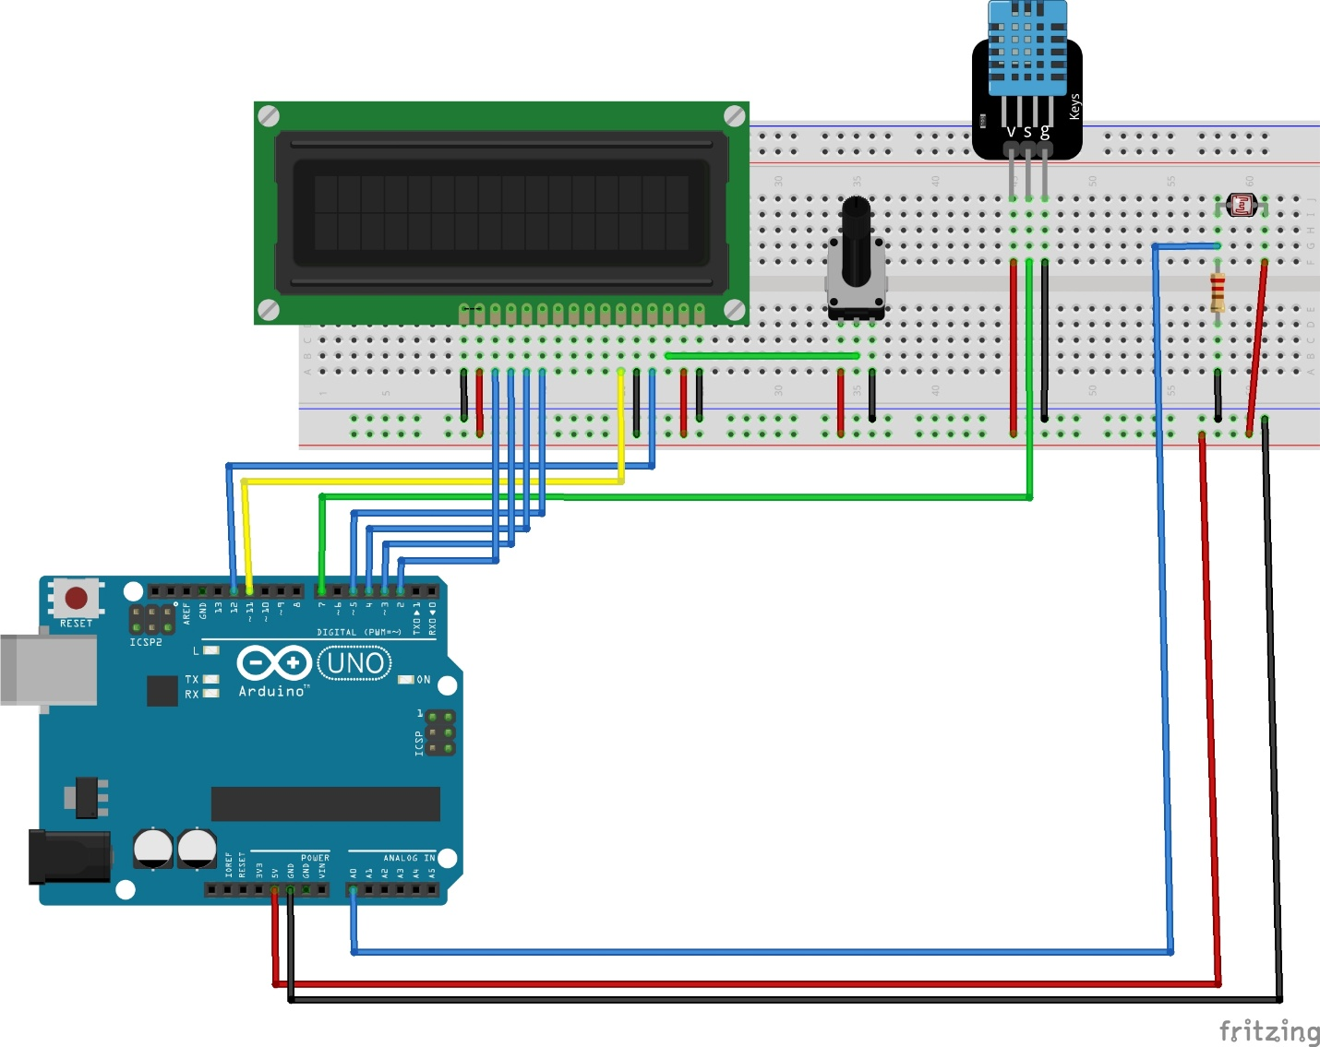

6. Circuit Design
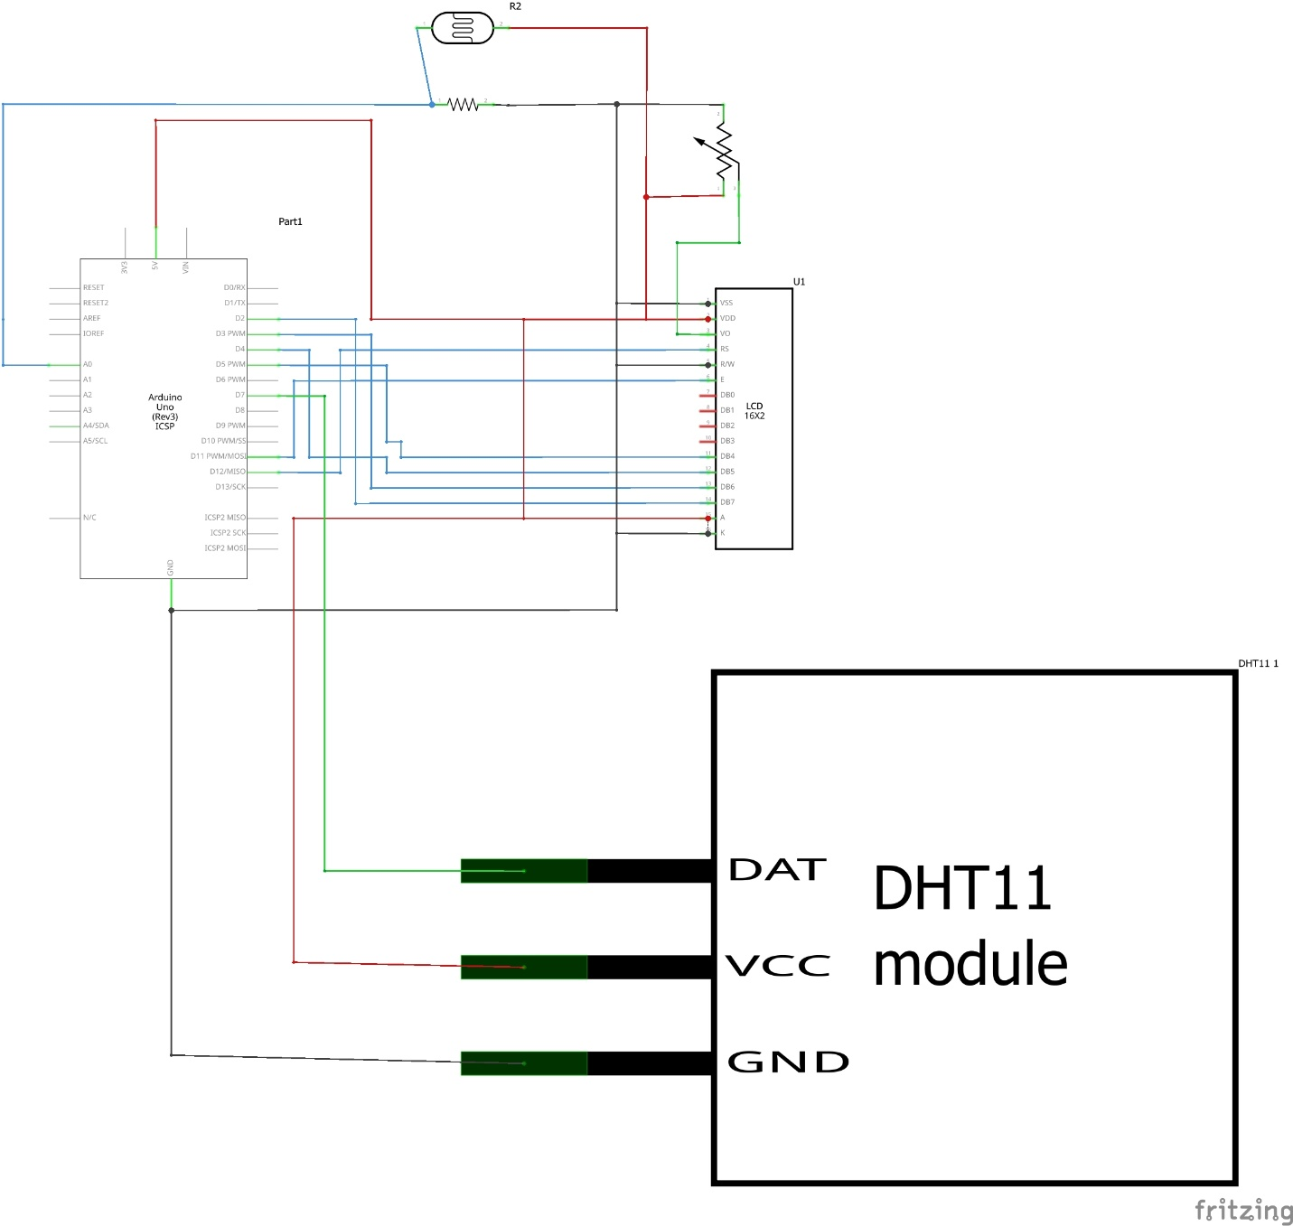

7. The Code
The main loop performs five steps: read the DHT11, read the LDR, check for errors, update the LCD, and send CSV data to the computer. A 2000ms delay follows each successful cycle; sensor reads and output make the total interval slightly longer than 2 seconds.
#include <LiquidCrystal.h> //Library inclusion to load external code before compilation
#include <DHT.h> //Library inclusion to load external code before compilation

#define DHT_PIN 7
#define DHT_TYPE DHT11
#define LDR_PIN A0

//Creates an LCD object specifying which Arduino pins connect to which LCD control pins
LiquidCrystal lcd(12, 11, 5, 4, 3, 2);

//Creates a DHT sensor object specifying which pin and which sensor model
DHT dht(DHT_PIN, DHT_TYPE);

void setup() {
//Opens serial communication at 9600 bits per second
Serial.begin(9600);
//Initialises the DHT sensor
dht.begin();
//Initialises the LCD and declares its physical dimensions (16 columns, 2 rows)
lcd.begin(16, 2);

//Startup message sequence to display for 2 seconds before measurements begin
lcd.setCursor(0, 0);
lcd.print("Env Monitor");
lcd.setCursor(0, 1);
lcd.print("Starting...");
delay(2000);
lcd.clear();
}

void loop() {
//Reads temperature and humidity from the DHT11
float temp = dht.readTemperature();
float humid = dht.readHumidity();
//Reads the LDR voltage divider and converts the ADC reading to volts
int raw = analogRead(LDR_PIN);
float volts = raw * (5.0 / 1023.0);

//Validates DHT11 readings before using them.
if (isnan(temp) || isnan(humid)) {
lcd.setCursor(0, 0);
lcd.print("DHT11 Error! ");
Serial.println("ERROR: DHT11 read failed");
delay(2000);
return;
}
//Updates LCD row 0 with temperature and humidity
lcd.setCursor(0, 0);
lcd.print("T:");
lcd.print(temp, 1);
// Prints the LCD degree symbol using character code 223
lcd.print((char)223);
lcd.print("C H:");
lcd.print(humid, 0);
lcd.print("% ");
//Updates LCD row 1 with light level voltage
lcd.setCursor(0, 1);
lcd.print("Light:");
lcd.print(volts, 2);
lcd.print("V ");

//Sends all three readings to the computer as CSV comma separated values
Serial.print(temp);
Serial.print(",");
Serial.print(humid);
Serial.print(",");
Serial.println(raw);

delay(2000);
}

8. Python Data Logger
Honest note about Python:
Python is still new to me. I understand what the logger does and I checked its output against the Serial Monitor before running the full session. I could not have written it from scratch on my own. Learning Python is something I am working on as the portfolio continues.
The Python logger runs on my computer while the Arduino runs separately. The Arduino sends one line of CSV data every 2 seconds over the USB cable. Python receives it, saves it, and eventually draws a graph. Here is what each step does:
- Opens COM6 at 9600 baud, same settings as Serial.begin(9600) in the Arduino code
- Reads one line at a time, each line looks like: 24.8,49.0,448
- Splits on the comma to get three separate values: temperature, humidity, raw light
- Converts text to numbers, calculates voltage from the raw value
- Keeps each valid reading with a timestamp in memory, then saves the collected readings to CSV when collection ends
- Runs until 1,800 seconds have elapsed, or until stopped early, then draws three plots and saves the graph. The submitted CSV contains 400 readings over 13 minutes 35 seconds.
One rule I had to learn: Serial Monitor and Python cannot both use COM6 at the same time. If the Serial Monitor is open when Python starts, Python gets nothing. I close the Serial Monitor before every logger run.

9. Problems I Ran Into
Problem 1: LCD showed nothing (RS and E on wrong pins)
What happened: the LCD backlight came on but nothing appeared on screen.
Cause: I had the RS wire on pin 11 and the E wire on pin 10. The code expects RS on pin 12 and E on pin 11. A one-pin offset on both wires.
How I found it: I turned the contrast potentiometer all the way through its range. Dark rectangles appeared on the screen. That told me the LCD hardware was fine but it was not receiving any data. I traced each wire back to its pin number and found the mismatch.
Fix: moved RS wire to pin 12, E wire to pin 11. Text appeared immediately.
Lesson: when an LCD shows nothing, check the contrast potentiometer first. Dark rectangles mean power and ground are correct but data is not arriving. That narrows the problem to the data wires (RS, E, D4–D7).

Problem 2: Serial Monitor showed labels not CSV
What happened: Serial Monitor was showing 'Temp: 24.6C Humid: 47%' instead of '24.6,47.0,447'.
Cause: I had written the Stage 3 CSV code in the editor but had not uploaded it. The Arduino was still running the older Stage 2 diagnostic code that printed readable labels.
Fix: uploaded the correct sketch. CSV format appeared straight away.
Lesson: the Arduino always runs the last uploaded sketch, not whatever file is open in the editor. Check the Serial Monitor output to confirm which version is actually running.

Problem 3: Python received nothing
What happened: Python ran without any error but no data appeared in the CSV file.
Cause: Serial Monitor was open in Arduino IDE. Both Serial Monitor and Python try to connect to COM6 at the same time. Serial Monitor got there first and was consuming all the incoming data.
Fix: closed Serial Monitor. Python immediately started receiving data.

10. The Three Events
During the logging session, I created three deliberate events to observe the sensors responding to environmental changes. The times and values below describe the submitted CSV and graph.

Event 1: Covering the LDR with my hand
Before covering: approximately 1.8–2.0V in room light.
During the main covered interval around 23:54:03–23:54:39: approximately 0.13–0.16V.
Estimated LDR resistance at 0.15V: approximately 323kΩ, using the divider equation.
Calculation: R_LDR = 10,000 × (5 / 0.15 − 1) ≈ 323,000Ω. The fall in voltage is consistent with the LDR resistance increasing when shaded. This estimate assumes the stated supply voltage and resistor value.
The light trace also contains smaller dips and fluctuations outside the main covered interval. Without a timestamped event diary, I cannot assign every fluctuation to a specific action.

Event 2: Breathing on the DHT11
Humidity immediately before the rise: 48% RH; recorded peak: 73% RH.
The humidity rise occurs around 23:59:09–23:59:28 and then declines toward the baseline.
Temperature immediately before the event: approximately 25.1–25.2°C.
Recorded temperature peak: 27.6°C. The response is consistent with warm breath reaching the sensor.

Event 3: Turning the room light off
Before lights off: approximately 2.0–2.2V.
During the sustained dark interval around 00:01:05–00:01:47: approximately 0.024–0.044V. The light level then recovers to approximately 2V before the log ends.
At 0.04V, the calculated LDR resistance is approximately 1.24MΩ. This is an illustrative estimate within the recorded dark interval.

11. Results: The Recorded Session
The submitted CSV contains 400 readings from 23:49:01 to 00:02:36, crossing midnight, for an elapsed span of 13 minutes 35 seconds. The three-panel graph shows temperature in red, humidity in blue, and light in gold. Its original “30 Minute Log” title reflects the configured duration rather than the duration of this recorded session.
- Temperature: falls from 25.2°C to a minimum of 24.2°C, rises gradually, then reaches 27.6°C during the breathing event. It declines to 26.5°C by the end, without fully returning to the earlier baseline.
- Humidity: ranges from 46% to 49% RH before the event, peaks at 73% RH, and declines to 49% RH by the end.
- Light: usually around 1.8–2.2V, with a sustained covered-sensor dip near 23:54 and a near-zero interval near 00:01. The light level recovers after both intervals. The recorded range is 0.024–2.253V.

12. Conclusion
Before starting this project I completed a series of hands-on exercises covering individual components, buttons, buzzers, servo motors, the HC-SR04 ultrasonic sensor, the LCD 1602 screen, and the DHT11 temperature sensor. Each exercise taught one component in isolation. Project 1 (LED Binary Counter) then combined buttons, LEDs, and debounce logic into a complete circuit. Project 2 was the next step, combining two sensors and a display: the DHT11, the LCD, and a new component I had not practiced individually, the LDR voltage divider. Going from one component at a time to these components working together was noticeably harder, and that difficulty is what made the project useful.
This was the most satisfying project so far because I could see the results in a graph at the end. Watching the three spikes appear exactly when I created the events, hand over the sensor, breath on the DHT11, lights off, confirmed that the sensors were measuring the real world, not generating random numbers.
The LCD debugging was the most frustrating part. The backlight came on so the hardware was clearly getting power. But nothing appeared on the screen. I spent time assuming the code was wrong before I found the one-pin offset in the wiring. The contrast potentiometer trick, turning it to show dark rectangles, told me the LCD panel was fine and the problem was in the data pins.
The aquarium I lost in Grade 8 had no data. I had no idea what was happening to the temperature, the light, or the pH over time. If I had built something like this project, I would have seen the problem coming before the fish died. That is the real reason this project matters to me.

